AIRLINES DATA PIPELINE DOCUMENTATION

Submitted by: Ushri Biswas
Email: ushri.biswas@msds.christuniversity.in

- DATASET DESCRIPTION
The given file contains Airlines data divided into 4 categories – flight information, booking information, passengers’ information and payments information. The descriptions/notes for each column value in each category/sheet as given below:

- FLIGHT INFORMATION:
Field | Type (as used) | Description/Notes
flight_id | identifier | Primary key for a flight data.
airline | text | Initially contained both UNKNOWN values and missing values
source | text | Departure city.
destination | text | Arrival city
departure_time | datetime (raw) | Time of departure of flight
arrival_time | datetime (raw) | Tentative arrival time of time – needed to be adjusted to that time of next day in case of overnight flight.

- BOOKING INFORMATION:
Field | Type (as used) | Notes
booking_id | identifier | Primary key for a booking.
flight_id | identifier (FK) | Links to flights.
passenger_id | identifier (FK) | Links to passengers.
status | text | Blanks filled with 'Unknown' and rows with status as ‘INVALID’ present
passport_number | PII (sensitive) | Need to be encrypted
emergency_contact_name | PII (sensitive) | Need to be encrypted.
emergency_contact_phone | PII (sensitive) | Need to be encrypted.

- PASSENGER INFO:
Field | Type (as used) | Notes
passenger_id | identifier | Primary key for a passenger.
first_name / last_name | PII (sensitive) | Combined into full_name, and later encrypted
email | PII (sensitive) | Encrypted and raw column dropped.
phone | PII (sensitive) | Encrypted and raw column dropped.
aadhaar_id | PII (highly sensitive) | Encrypted and raw column dropped..
age | numeric | Passed through to the merged output.
gender | text | Passed through to the merged output.

- PAYMENTS INFO:
Field | Type (as used) | Notes
booking_id | identifier (FK) | Links to bookings.
amount | numeric / text | Blanks filled with 'Unknown' and rows with amount as 'INVALID' are present
payment_method | text | Passed through to the merged output.

- ARCHITECTURE DIAGRAM:
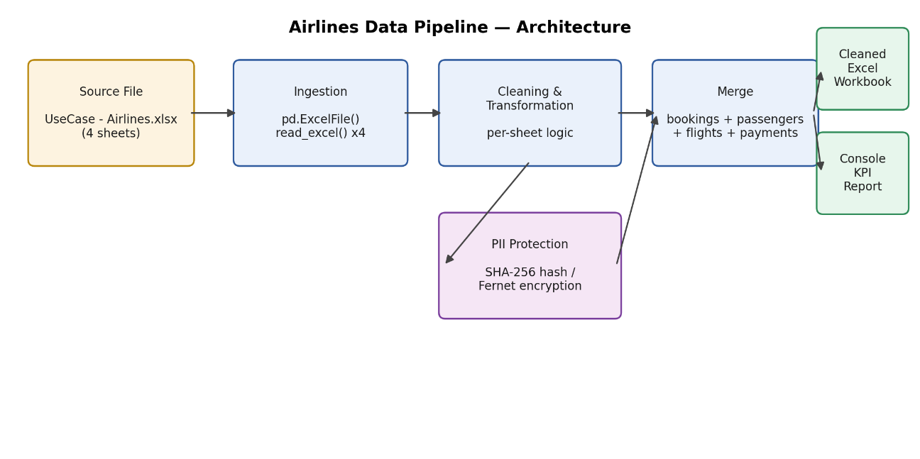

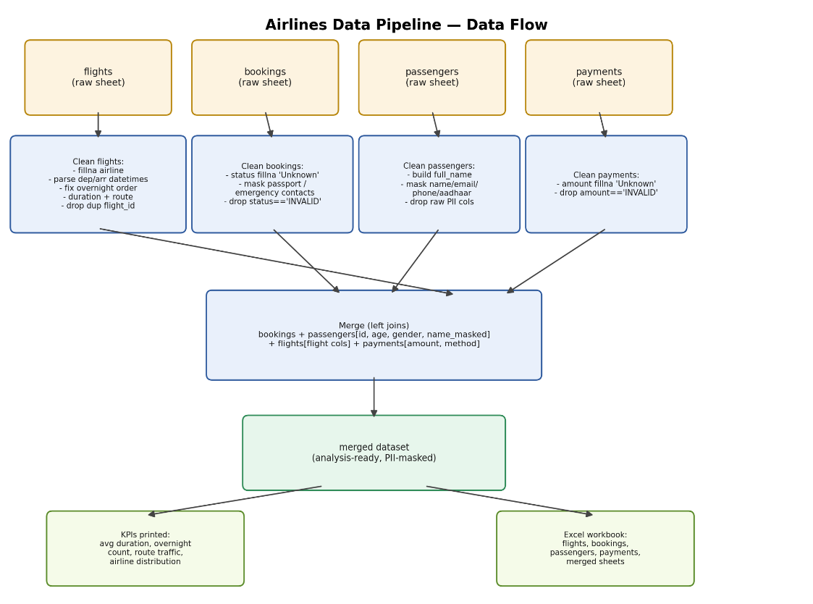
- DATA FLOW DIAGRAM:

- ASSUMPTIONS:
i) Missing or 'UNKNOWN' airline values can be temporarily marked as 'Unknown Airline' until authoritative vendor records are fetched.
ii) Any flight where the recorded arrival_time is earlier than the departure_time represents a flight spanning past midnight into the next day.
iii)Rows containing explicit 'INVALID' strings in status or payment fields represent unrecoverable information and hence, must be removed.
iv)The key for decryption of passenger info is not included in final pipeline and kept safely for usage of authorised personnel only.

- DATA CLEANING LOGIC/STRATEGY:
The Python script sets up a data processing pipeline for an airline system. It begins by generating a Fernet key, which uses symmetric encryption so sensitive fields can be encrypted and later decrypted by authorised individuals. The pipeline ingests four sheets from an Excel workbook (flights, bookings, passengers, and payments).
In the cleaning step, the script corrects flight timing anomalies. Flight datasets frequently record overnight flight arrivals with time components that appear smaller than their corresponding departure times due to passing midnight. The pipeline checks for this condition (arr_dt < dep_dt) and adds a 24-hour offset (pd.Timedelta(days=1)) to compute the corrected arrival time. It then calculates total flight duration in minutes and sets a flag for overnight flights. Duplicate flight entries are dropped based on flight_id and departure_time.
For privacy protection, raw sensitive information—such as full names, emails, phone numbers, Aadhaar IDs, passport numbers, and emergency contact details—is encrypted using the encrypt() helper function, which relies on fernet.encrypt(). The original unencrypted columns are removed to prevent sensitive data leaks.
Invalid data rows containing explicit 'INVALID' flags in the status and amount columns are stripped. Missing categorical attributes are imputed with default placeholders such as 'Unknown Airline' or 'Unknown'.
Finally, the pipeline merges all four tables using passenger_id, flight_id, and booking_id foreign key joins. It writes the individual cleaned tables alongside a consolidated merged sheet into a new Excel output file (cleaned_airlines_data_trial_encrypted.xlsx). It finishes by printing system KPI metrics to the console, including average flight duration, overnight flight counts, route traffic volume, and airline distribution metrics.

